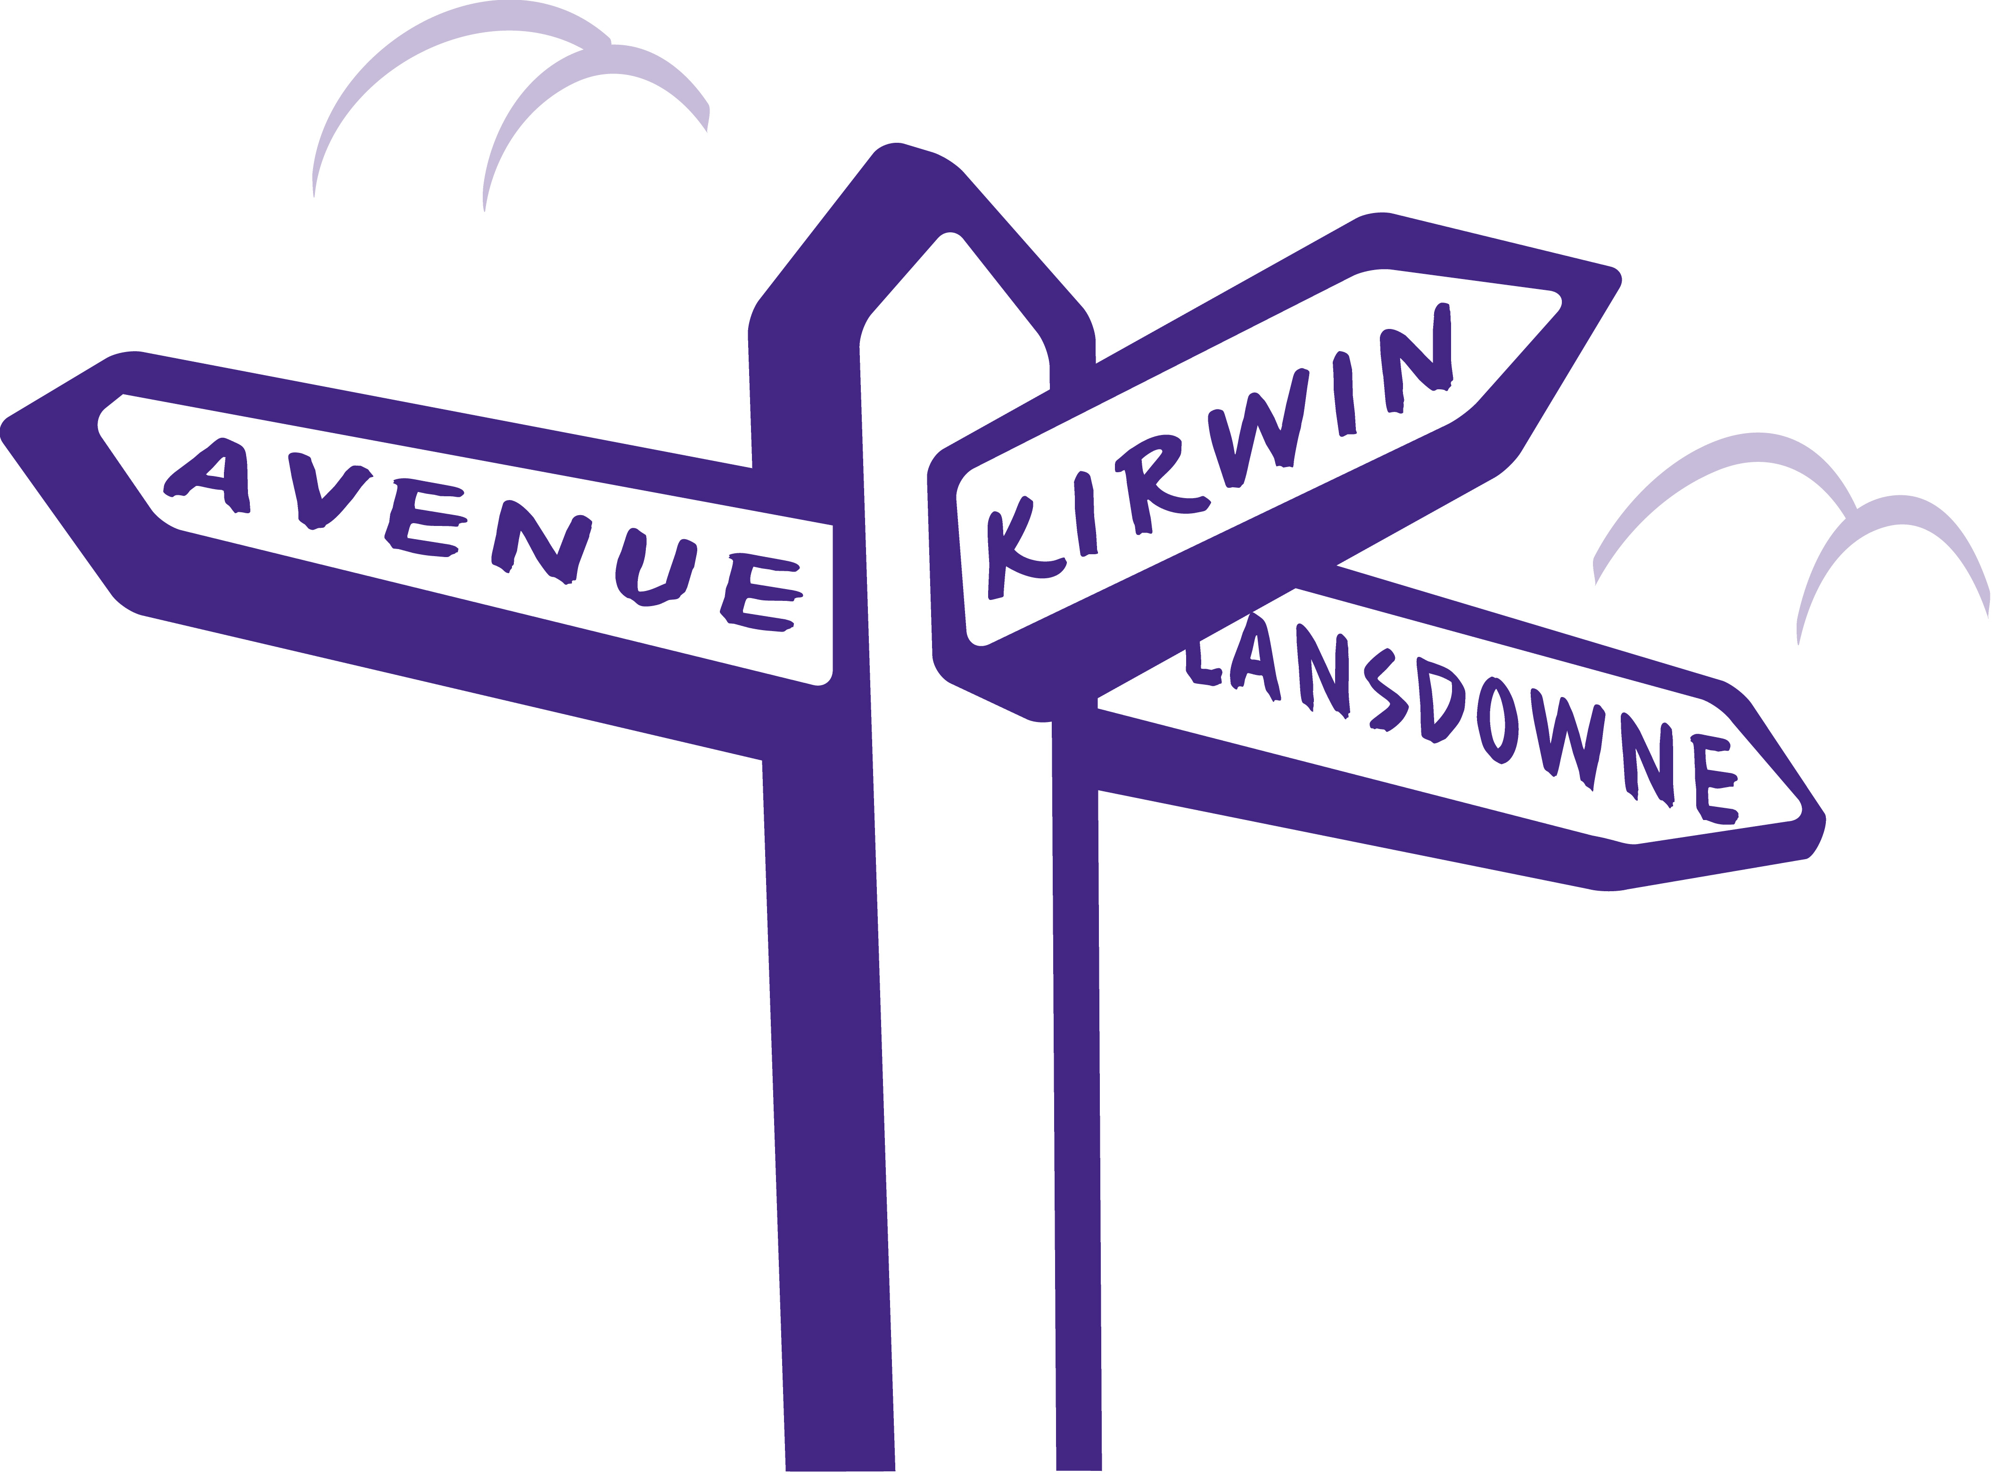

COMPLAINTS POLICY

INTRODUCTION

WEFHS wants tenants, their families and others involved to feel confident that any complaint will be taken seriously and acted upon. This document is provided to make sure everyone is aware of the procedures for making a complaint.

This Complaints Policy explains our complaint handling approach which is aligned to meet the Housing Ombudsman’s Complaint Handling Code.

SCOPE

This policy applies to all tenants of WEFHS, and to family, friends or other representatives acting on their behalf. In this policy we use the word “tenant” to refer to anyone in these categories. It is also applicable for our suppliers, stakeholders, and the general public and anyone who works with us.

We want to make it as easy as possible for tenants and ensure they are fully supported when making a complaint. We understand that they may wish to make a complaint in a way which suits their needs.

The policy must be followed by all staff and board members. Complainants should be assured that all concerns and complaints will be treated seriously and confidentially.

A complaint includes any dissatisfaction with acts or omissions by WEFHS or its staff. It also includes any potential dispute with another tenant.

This policy also covers any request for a change or improvement in our services or housing standards.

It should be noted that a complaint is where you have an issue with the processes and procedures of WEFHS have not been followed. The complaints procedure should not be used to report building or maintenance issues. This should only be used if you are dissatisfied with repairs or if you do not think response periods have been followed.

Persistent or unreasonable complaints may be made very occasionally, where the customer or their representative will not accept the matter is concluded despite having their complaint investigated or they may repetitively make substantially similar complaints. If a member of staff feels that a complaint has become persistent or unreasonable, they must refer to the Manager to discuss with the Board.

DEFINITION OF A COMPLAINT

Our definition of a complaint, in line with that used by the Housing ombudsman, is:

An expression of dissatisfaction, however made, about WEFHS or a member of staff’s, or a partner’s:

• action, or
• lack of action, or
• standard of a service

which affects an individual tenant or a group of tenants.

A tenant does not have to use the word ‘complaint’ for it to be treated as such. Whenever a tenant expresses dissatisfaction we will give them the choice to make complaint. A complaint that is submitted via a third party or representative will be handled in line with the complaints policy.

Service requests

There is a difference between a service request and a complaint. A service request is a request from a tenant to the landlord requiring action to be taken to put something right, for example a repair is required. Service requests are not complaints, but will be recorded, monitored and reviewed regularly. A complaint must be raised if you express dissatisfaction with the response to your service request, even if the handling of the service request remains ongoing.

WHEN IT ISN’T A COMPLAINT

- Where legal proceedings have commenced and continuing would not be appropriate.
- The issue giving rise to the complaint occurred over twelve months ago.
- Claims made against WEFHS’s business insurance cover.
- Safeguarding Referrals.

Complaints covered by the above exclusions will not be dealt with in accordance with this Complaints Policy, but through other more relevant procedures, which will better serve the resolution of the issue raised. Tenants will be supported to ensure issues raised are appropriately directed.

VALUES STATEMENT

This policy should be understood and implemented within the context of the WEFHS values statement.

HOW OUR COMPLAINTS PROCESS WORKS

We have a two stage complaints process which is detailed below, although we aim to resolve all complaints where possible at the first point of contact.

We aim to resolve all complaints within the Housing Ombudsman’s Complaint Handling Code’s timescales. If this is not possible (by rare exception only), we will communicate a realistic timescale and explain the reasons why this has not been possible.

At any point tenants can access support from dispute support advisors at the Housing Ombudsman, not only when the complaints process has been completed. The advisors are able to assist tenants throughout the life of a complaint. See below for contact information.

STAGE 1

The majority of our complaints are resolved at Stage One. We aim to make decisions to put things right for our tenants, pay compensation where appropriate and uphold the tenant’s right to a fair process.

Once you tell us you wish to make a formal complaint we will:

- Acknowledge your complaint within 5 working days with a reference number and contact details of the person who will deal with the complaint and signpost you to this policy.

- Register your complaint and review the issues presented and will:

- Contact you to discuss the complaint in full, check the scope of the complaint, the details of the situation and give you fair opportunity to set out your position and establish what resolution you are seeking.
- Check if any reasonable adjustments are required to support you during the complaint process.
- Agree contact during the investigation and reconfirm the expected response timescale or agree a reasonable extension of up to a maximum of 10 days, should your complaint be more difficult to investigate, require actions or external partners to support the investigation.
- Keep you informed of progress.

We will conduct an unbiased, empathetic, and thorough investigation of the complaint and give you an opportunity to comment on any adverse findings before any decision is made. We will inform you of our decision and confirm this in writing within 10 working days of the complaint being received.

Where future work is required to resolve a complaint, an agreed schedule will be provided so you can monitor completion. This will clearly identify when you should expect action to take place. Completion of this work will be monitored and followed up by the Stage One complaint handler.

We will advise how to escalate your complaint if you’re still not satisfied and provide information and support on how to contact the Housing Ombudsman if you require impartial advice.

STAGE 2

What happens if you’re still not satisfied?

Once you have received our response letter, if you remain dissatisfied, please:

- Advise us that you wish to escalate your complaint within 10 working days.
- Let us know why you feel the matter has not been resolved.

Once we have received your request for escalation, we will:

- Acknowledge your complaint escalation within 2 working days.
- Escalate the complaint to an appropriate Manager or Board Member who will lead a thorough and independent review of the stage 1 findings.

The Stage Two Review Manager will contact you to discuss the complaint in full and check the reasons for the complaint escalation and give you a fair opportunity to set out your position and establish the resolution you are seeking.

During the review we will:

- Check if any reasonable adjustments are required to support you during the complaint process.
- Agree contact to keep you informed during the review and reconfirm the review timescale or agree a reasonable extension of up to a maximum of 10 days should this support the review’s thoroughness.
- Lead an unbiased, empathetic and thorough review of the complaint drawing in the expertise of other senior colleagues and/or Tenant representatives (where consent has been provided) and give you an opportunity to comment on any adverse findings before any decision is made.
- Inform you of their findings and confirm this in writing within 20 working days of the Stage Two complaint being received.
- Where future work is required provide an agreed schedule so you can monitor completion. This will clearly identify when you should expect action to take place. Completion of this work will be monitored and followed up by the Stage Two Review Manager.
- Provide advice and support on how to escalate your complaint to the Housing Ombudsman if you are still not satisfied.

In some cases, the Stage Two Review Manager may feel it is appropriate to allow your complaint to be referred to the Housing Ombudsman for review before the end of the Stage Two review process. For example, they may feel that your complaint has already exhausted the complaints procedure. This action would only be taken where it is felt it is not in the tenant’s interests to go through a further stage of the WEFHS complaints process and that continuing would result in the same outcome and an unnecessary delay in the tenant’s ability to access the Housing Ombudsman’s mediation service. This will also apply where an exclusion ground (identified above) has been identified following the Stage 1 review. Where WEFHS declines to escalate a complaint we will clearly communicate in writing our reasons for not escalating and provide information regarding access to the Housing Ombudsman.

Once a Stage Two review has been completed, if you are still not happy with how we have dealt with your complaint you can refer your complaint directly to the Housing Ombudsman.
The Ombudsman will carry out a full confidential investigation asking us to provide information to help make their decision. At the end of the investigation, they will write to you and to us, to set out their decision and explain how they arrived at it. They will then recommend how the problem should be solved.

The contact details are:
Housing Ombudsman Service,
PO Box 152
Liverpool
L33 7WQ
Telephone: 0300 111 3000.
Fax 020 7831 1942

Email: info@housing-ombudsman.org.uk
Website: http://www.housing-ombudsman.org.uk

REVIEW

This policy will normally be reviewed triennially to ensure that it reminds fit for purpose, unless an earlier review is required due to regulatory, statutory or other requirements.

A member of the Board (usually the Chair) will be appointed to have lead responsibility for complaints to support a positive complaint handling culture. This role will be responsible for ensuring the Board receives regular information on complaints that provides insight on the Society’s complaint handling performance. This will include regular updates on the volume, categories and outcome of complaints, alongside complaint handling performance including compliance with the Ombudsman’s orders.

A record of all complaints received will be kept and reviewed annually by the Board in order to identify issues and trends, learn from complaints and improve our services.

TENANT DISPUTES

Tenants making complaints about another tenant must be aware that there is a limit to the powers that WEFHS has as a landlord. Whilst we will make every effort to resolve tenant disputes in stage 1, WEFHS is only able to take formal action against a tenant if they are in breach of their tenancy agreement. Tenancy agreements specifically refer to anti-social behaviour. Please read the Anti-Social Behaviour procedures in conjunction with this policy.

Whilst there is a responsibility of all tenants to manage relationships within a community such as WEFHS we understand that neighbour disputes do occur. In order to resolve such matters, you may both be asked to engage with mediation in order to resolve any dispute.

CONFIDENTIALITY

We will treat ALL complaints in confidence and only pass details to staff and others who need to know in order to investigate it. However, where someone is considered to be at risk the WEFHS Safeguarding Policy will apply and WEFHS may have to share the information with other agencies. Further information may be found in the Safeguarding Policy

GUIDING PRINCIPLES FOR DEALING WITH COMPLAINTS

Simplicity: Simple, well publicised stages.

Access: Complainants knowing exactly where, how and to whom they should complain.

Speed and clarity: Complaints being dealt with promptly, effectively and professionally within the stated time limits and at the earliest stage possible.

Action: Action being agreed and reviewed, with complainants kept informed of progress throughout each stage of the procedure.

Objectivity: Beyond the first stage of investigation of a complaint against an individual, the subject of the complaint will not deal with it but instead refer it to their manager.

Development: Opportunities for the organisation to review practice and consider changes to the procedures.

